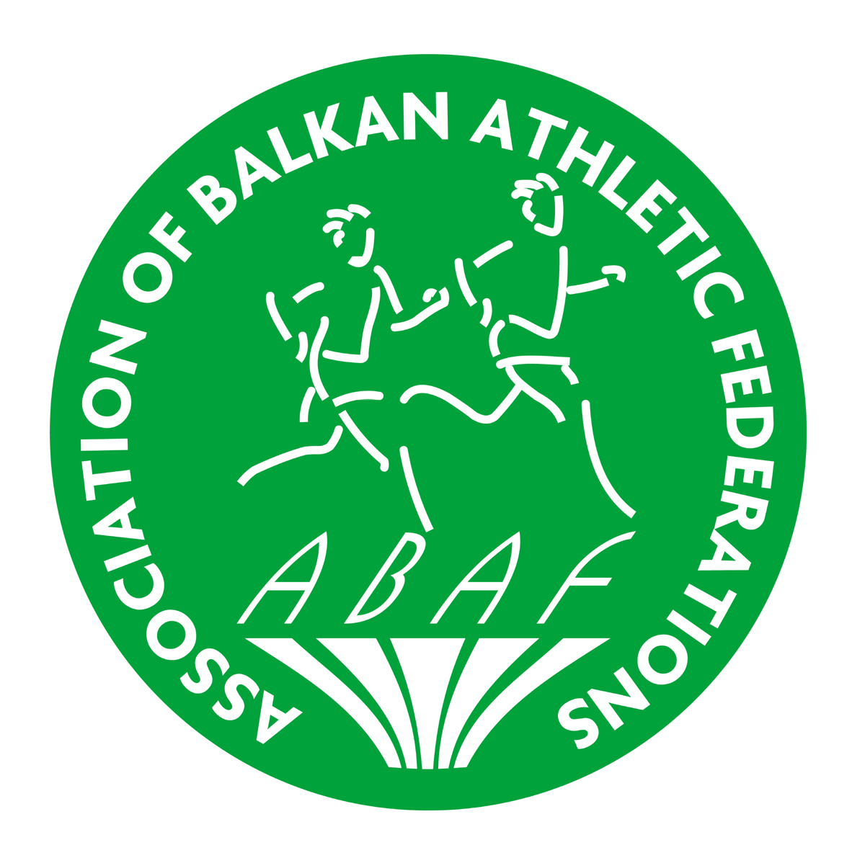 | BALKAN YOUTH ATHLETICS  CHAMPIONSHIPS  Serbia, Sremska Mitrovica, 04 July 2015. | 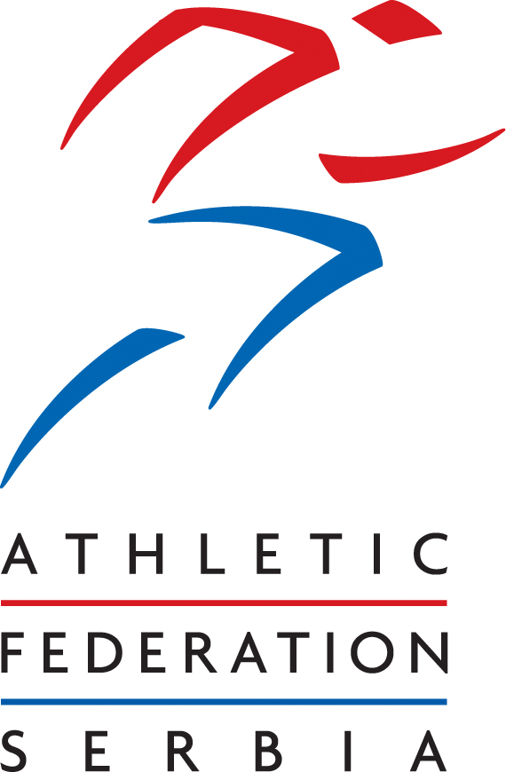

PRELIMINARY ENTRY FORM
Country:
Country Code:

 | MEN | WOMEN | TOTAL
Competitors
Team leaders
Technical leaders
Officials
Coaches
Doctors
Physiotherapists
Drivers
TOTAL

Arrival |  |  | Departure
Date of arrival |  |  | Date of departure
Time of arrival |  |  | Time of departure
Means of transport |  |  | Means of transport

This form has to reach the office of Athletic Federation of Serbia,
not later than 25 May 2015.
e-mail: office@serbia-athletics.org.rs or momirovic@serbia-athletics.org.rs

Name |  | Position
Signature |  | Date

